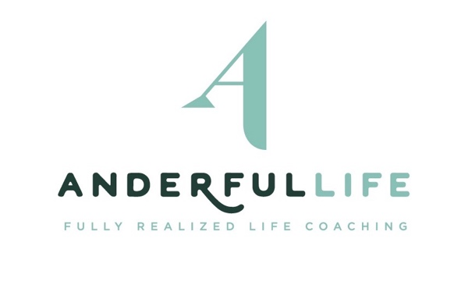
Faith Sifting Registration Form
- Please type to complete form.
- Return completed form to kristin@anderfullife.com

About you
Name:

Address: | Street  City, State Zip
Email:

Phone: |  | Is texting this number OK? | Yes  o | No  o
The question(s) I’m
holding is(are):

Session – Select the Section you’re interested in

o Section 1:
- Group Sessions – Fridays @ 12:00-1:15 pm. (Central Time), March 13, 20, 27, April 10 and 17 (No session April 3)
- Individual coaching session – Available any time on or before April 17.

o Section 2:
- Group Sessions - Mondays @ 7:00-8:15 p.m. (Central Time), March 9 – April 6
- Individual coaching session – Available any time on or before April 17.

Payment (Electronic Payments Only):

o Option 1 – Payment in Full ($300)

o Option 2 – Six payments of $50 each (first charged when registration is received + five remaining payments charged Monday morning that each group session meets).

Electronic Payment information:
Name on Card:
Card:
Expiration Date:
Security Code (back of card):

Participant Consent:
I understand that my participation in Faith Sifting is voluntary, and decisions made through the process are my own. I give Anderful Life permission to charge my card as indicated above. Further, I understand that once the group has begun, there are no refunds. In the case of illness or the death of a loved one, a make-up session will be scheduled with Kristin.
__________________________________________________________ ________________________
Signature Date

